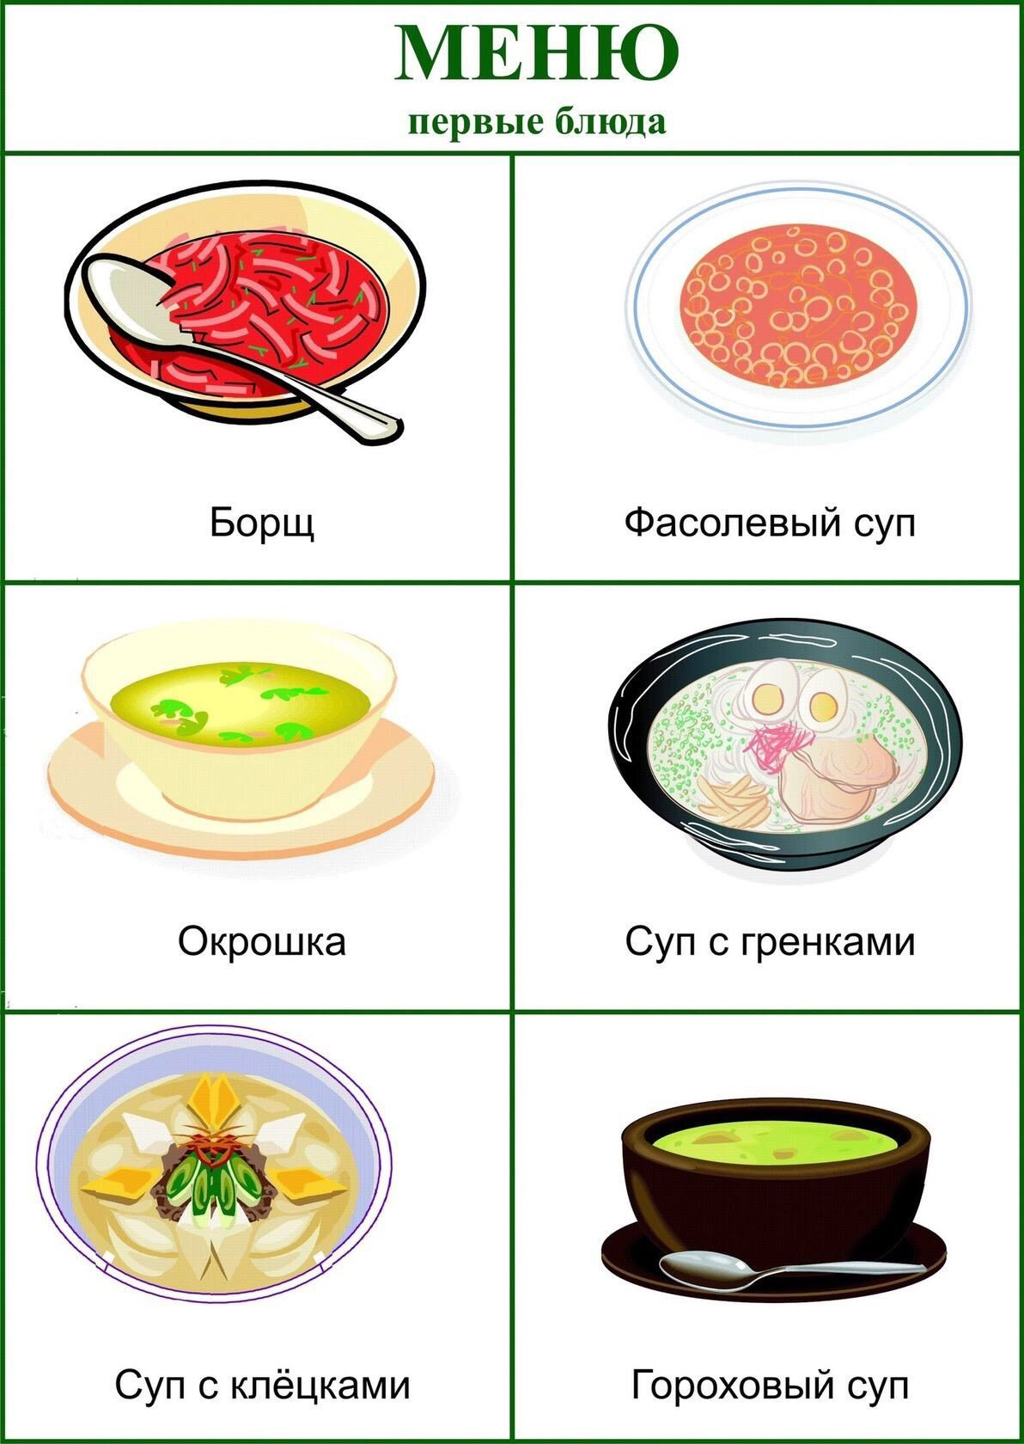

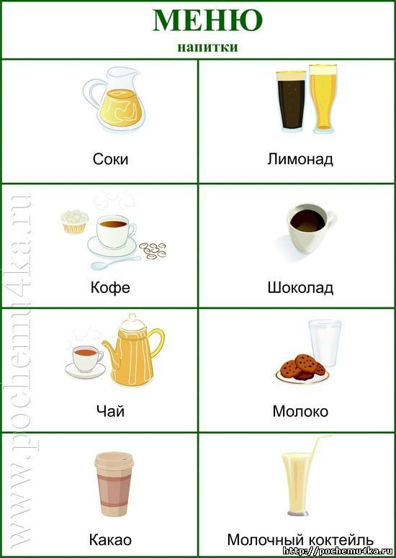

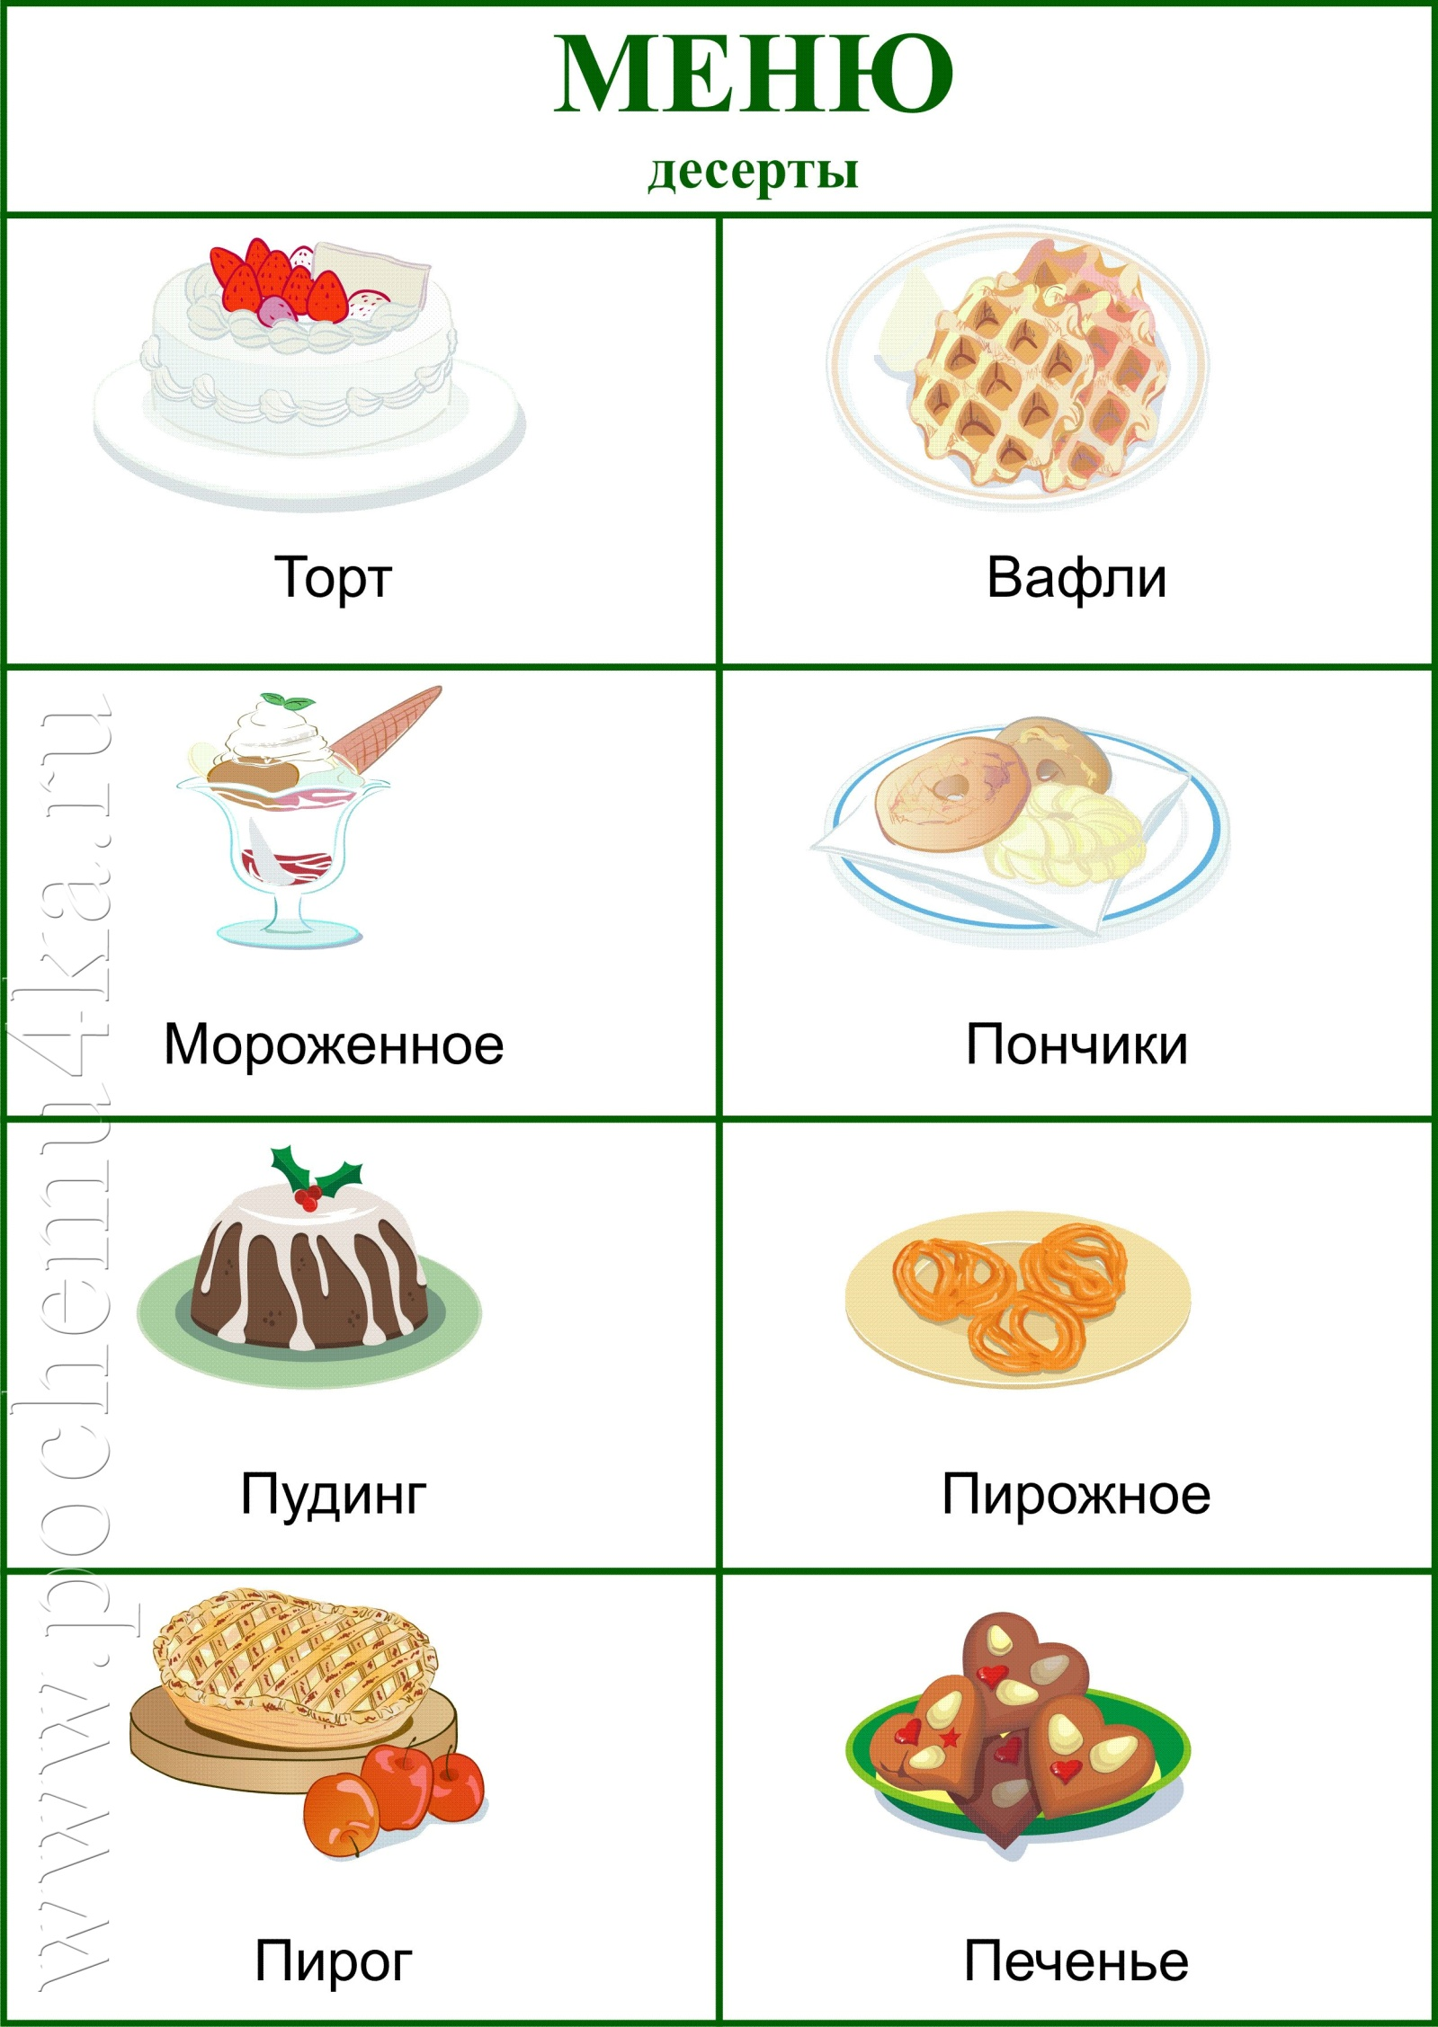

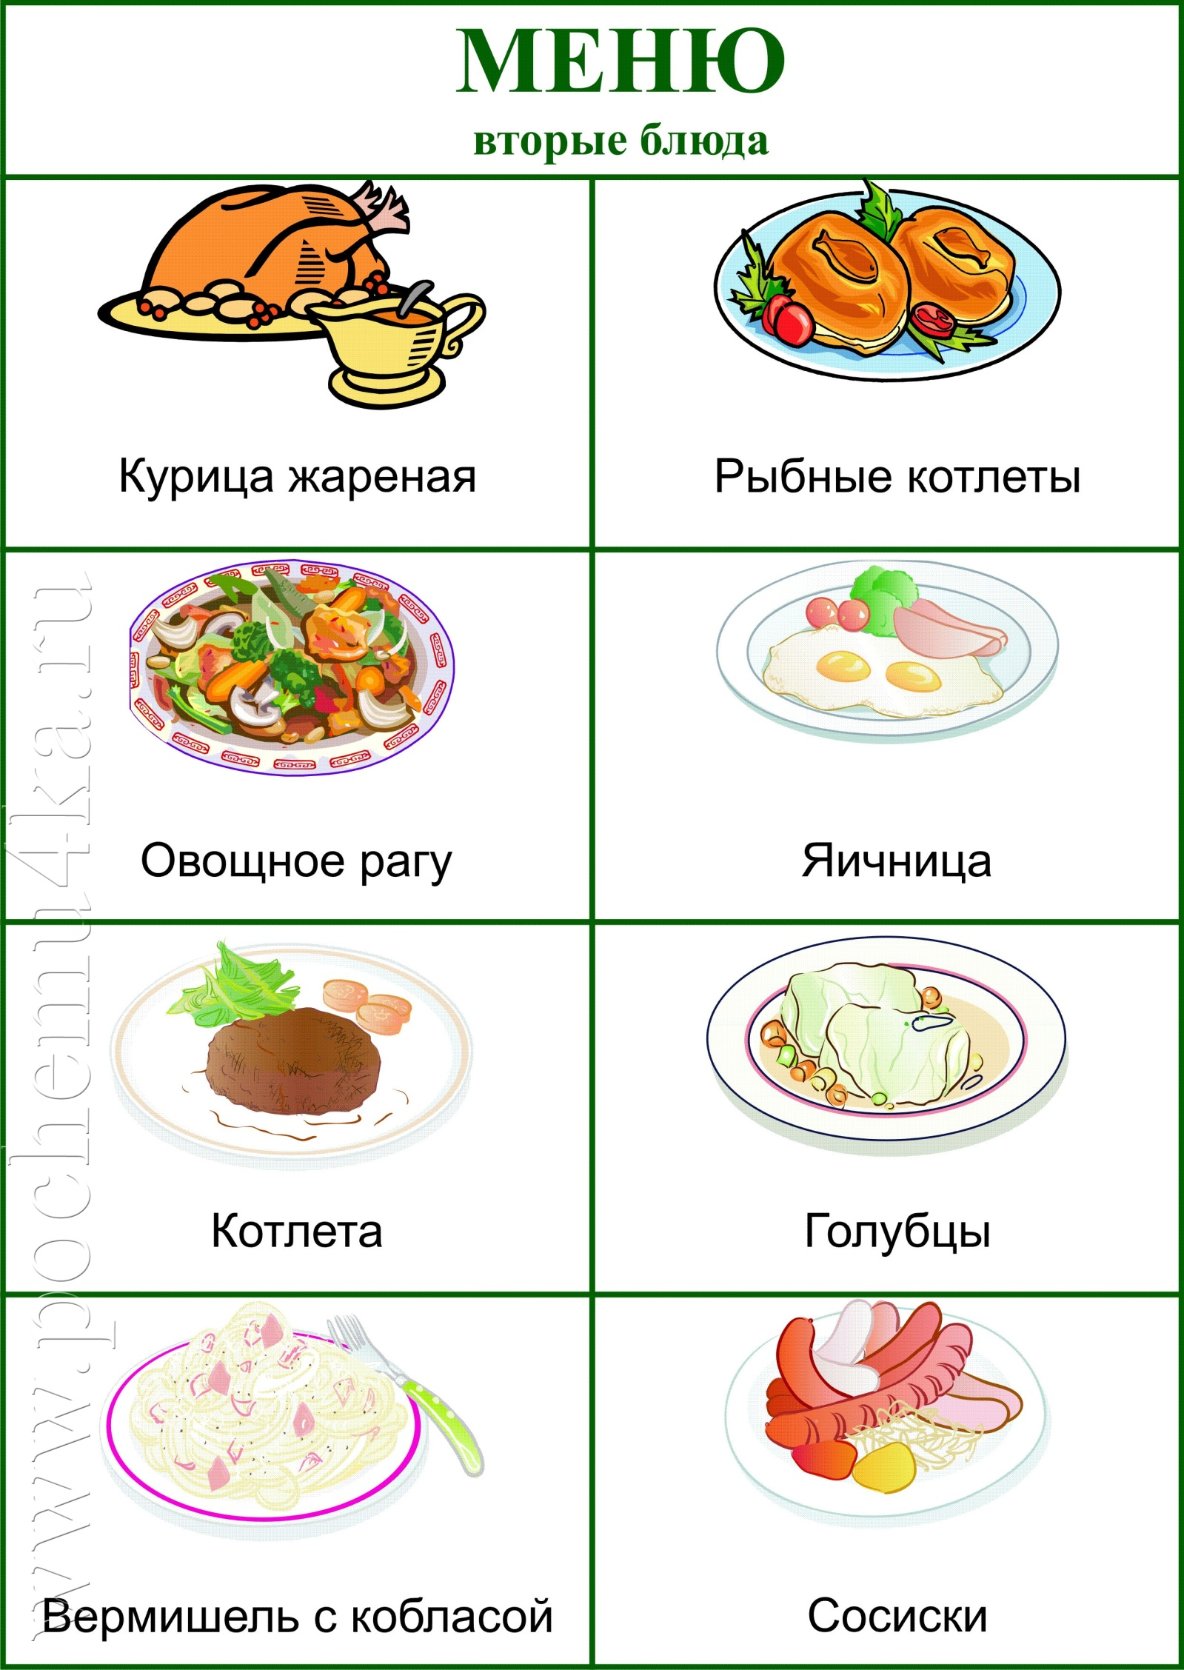

|  |  |
| --- | --- |
| C:\Users\User\Desktop\fc5466f139441abb3573.jpeg | C:\Users\User\Desktop\scale_1200.jpg |
| C:\Users\User\Desktop\5642930_1920.jpg | C:\Users\User\Desktop\1610990334_150695.jpg |
| C:\Users\User\Desktop\5c089e17c92787310816da39.jpg | C:\Users\User\Desktop\11617.jpg |
| C:\Users\User\Desktop\Depositphotos_182993900_l-2015.jpg | C:\Users\User\Desktop\LUnD9CNiD6o.jpg |